**WORLD**

**YOUTH**

**FUNDAY**

|  |
| --- |
|  |

**Where are we? Label the United Kingdom to show where we live.**

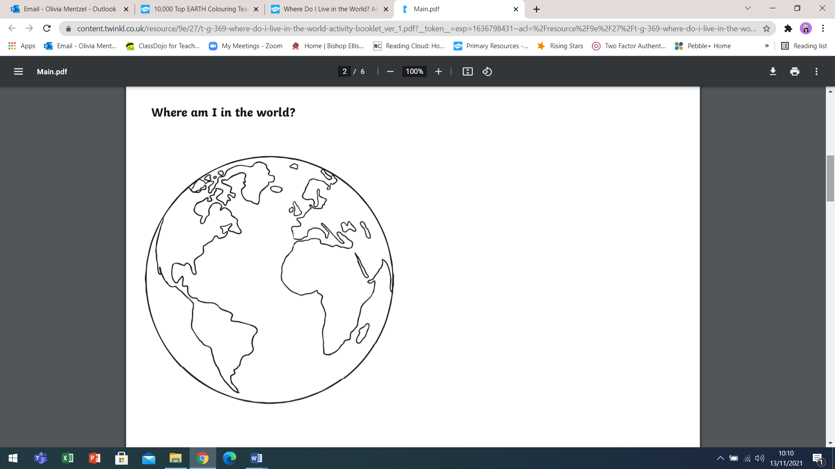**Challenge: Can you label any other countries/continents?**

|  |
| --- |
| **Write a list of things you love about the world we live in:** |

**Around the image, write at least 10 things we can do to help look after our planet.**

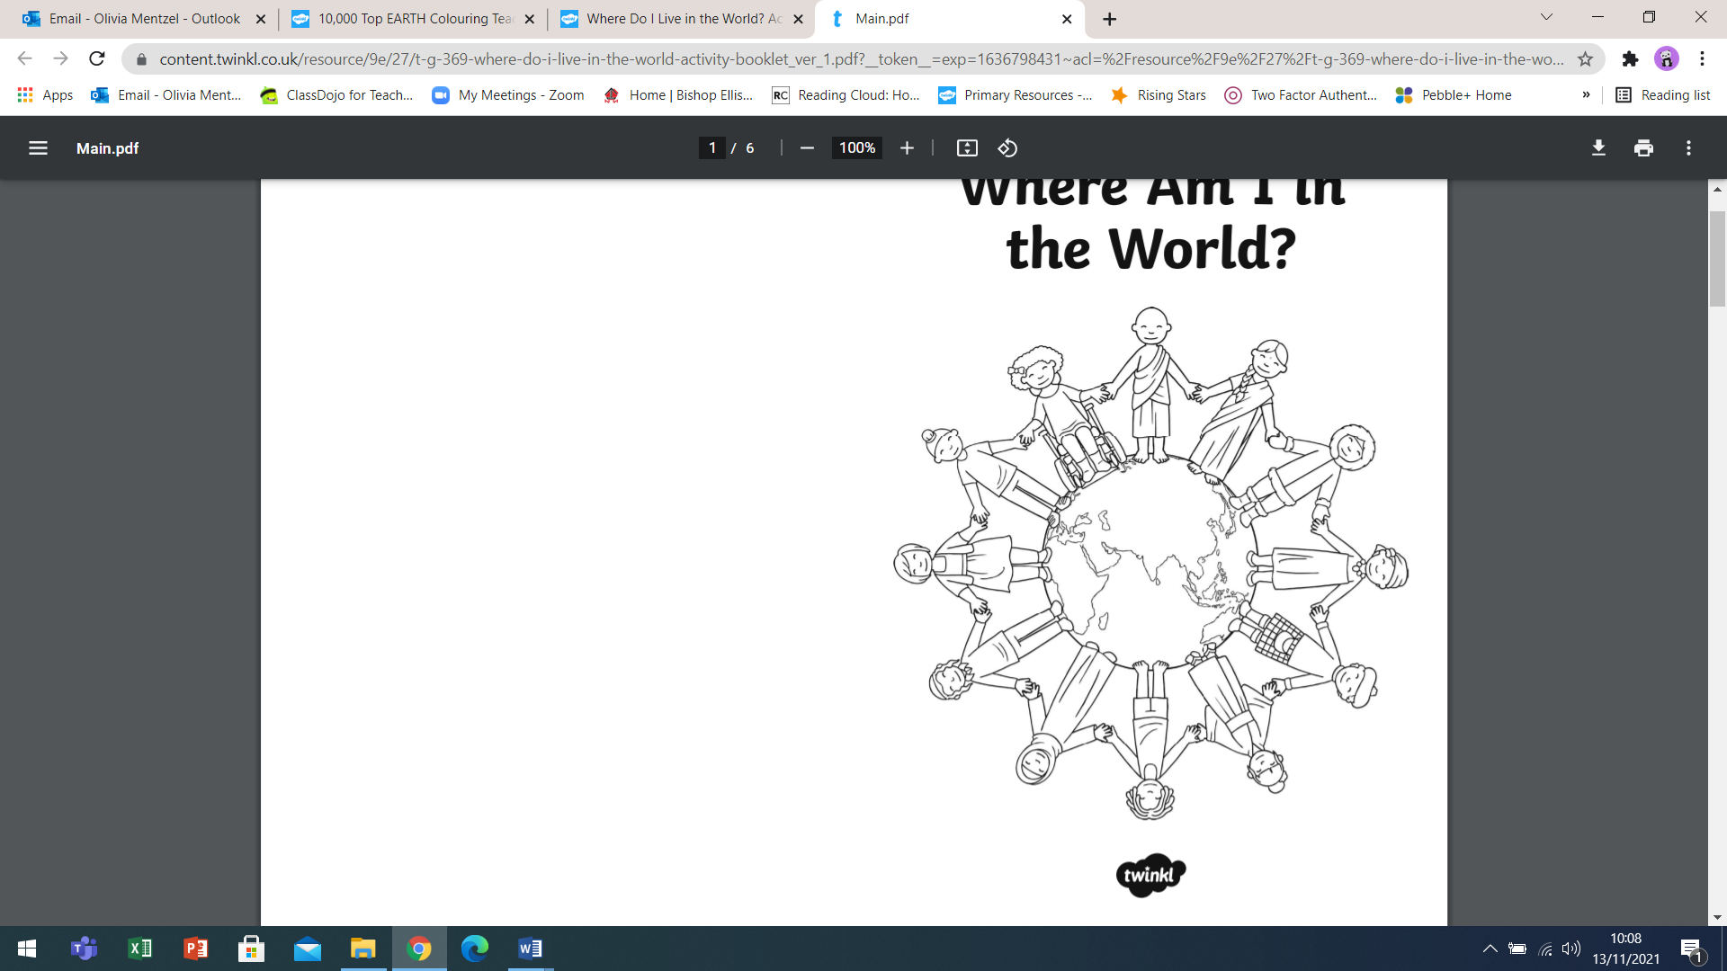

|  |
| --- |
| Take a moment to reflect on CAFOD’s prayer for our world.    **Use the space below to record your own prayer and decorate around it with relevant images.**  ________________________________________  ________________________________________  ________________________________________  ________________________________________  ________________________________________  ________________________________________  ________________________________________  ________________________________________  ________________________________________  ________________________________________  ________________________________________  _________________________________________  _________________________________________  _________________________________________ |

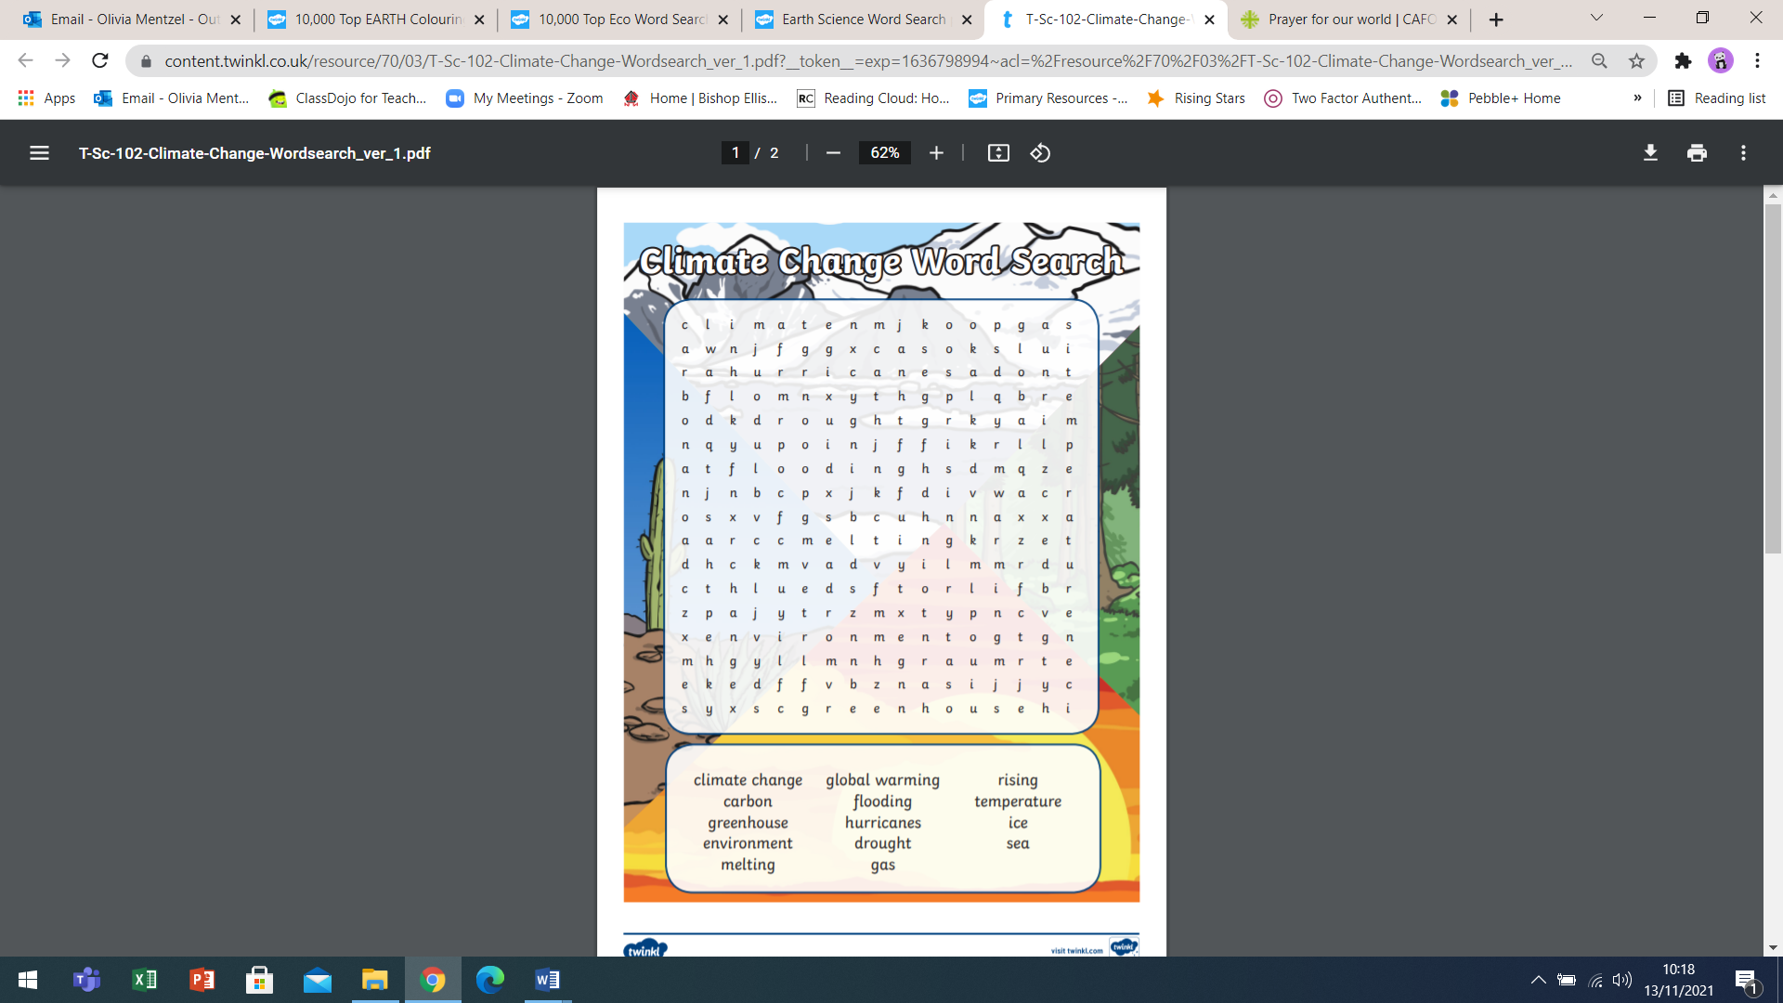

|  |
| --- |
| ____________________________________________________________________________________________________________________________________________________________________________________________________________________________________________________________________________________________________________________________________________________________________________________________________________________________________________________________________________________________________________________________________________________________________________________________________________________________________________________________________________________________________________________________________________________________________________  ____________________________________________________________________ |

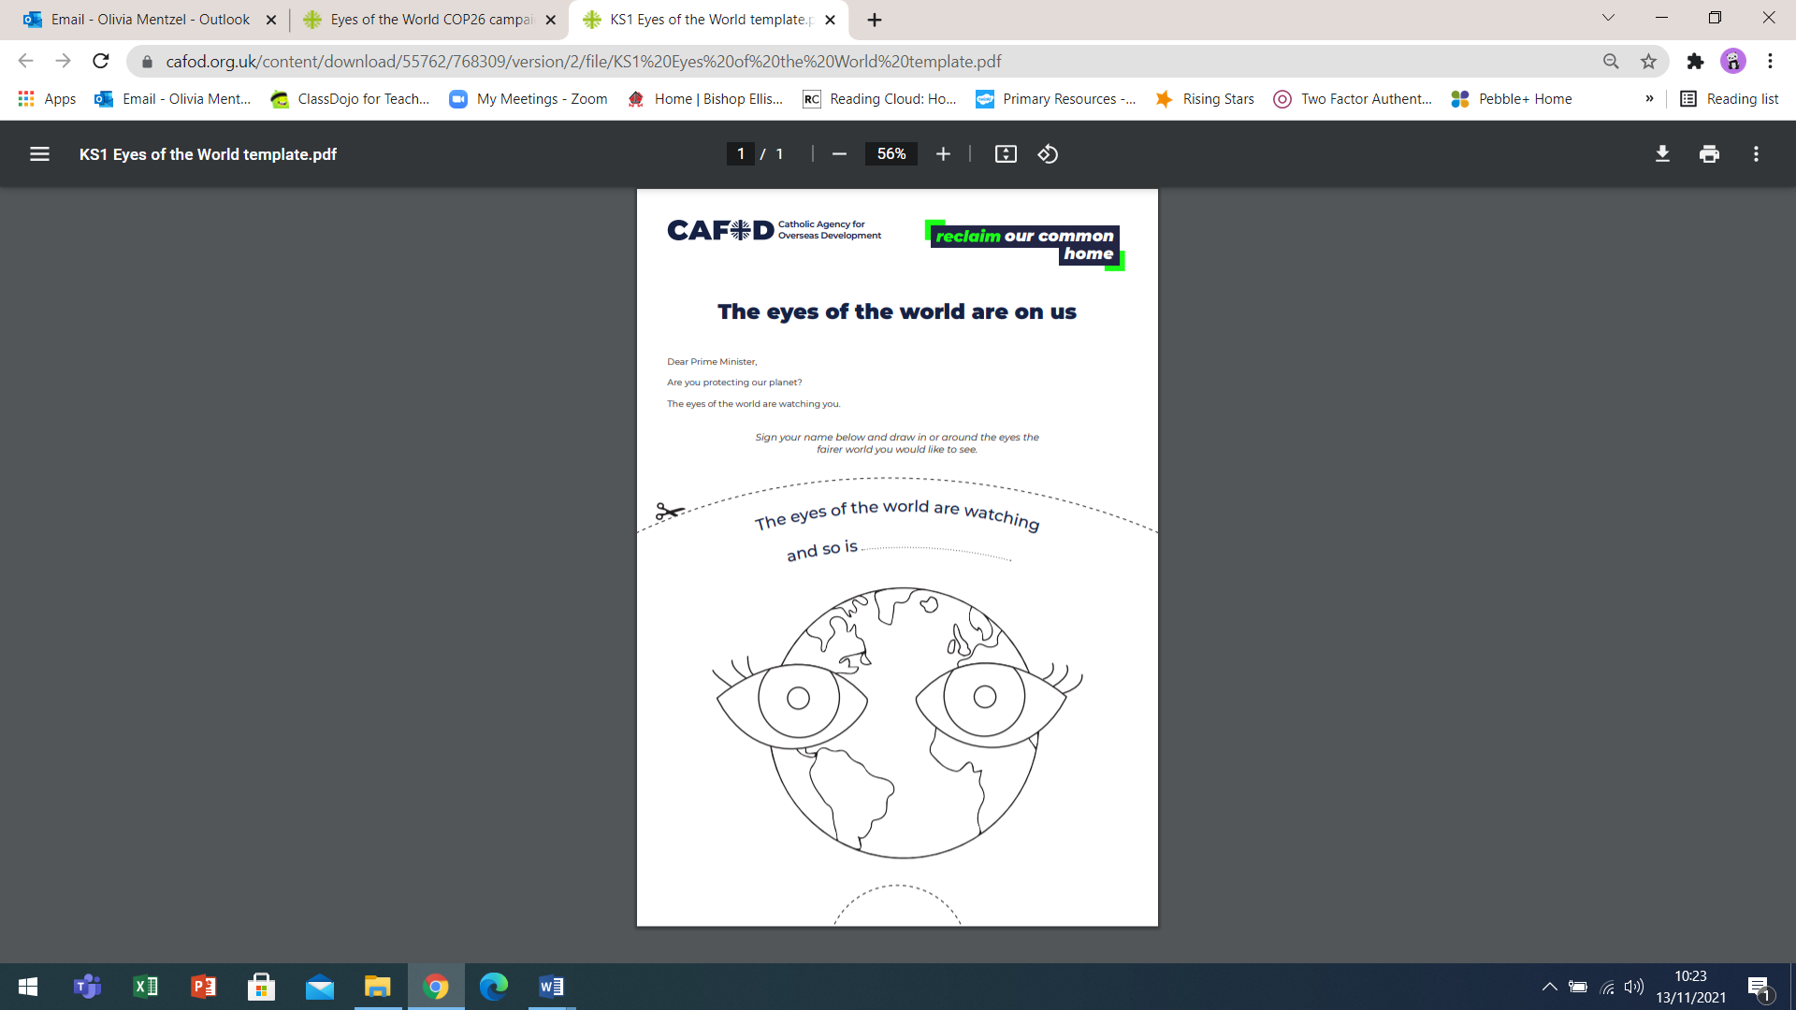

**What does this image show?** ____________________________________________________________________________

**What are the characters in the image doing?** _____________________________________________________________

**How is this image impactful?** ___________________________________________________________________________

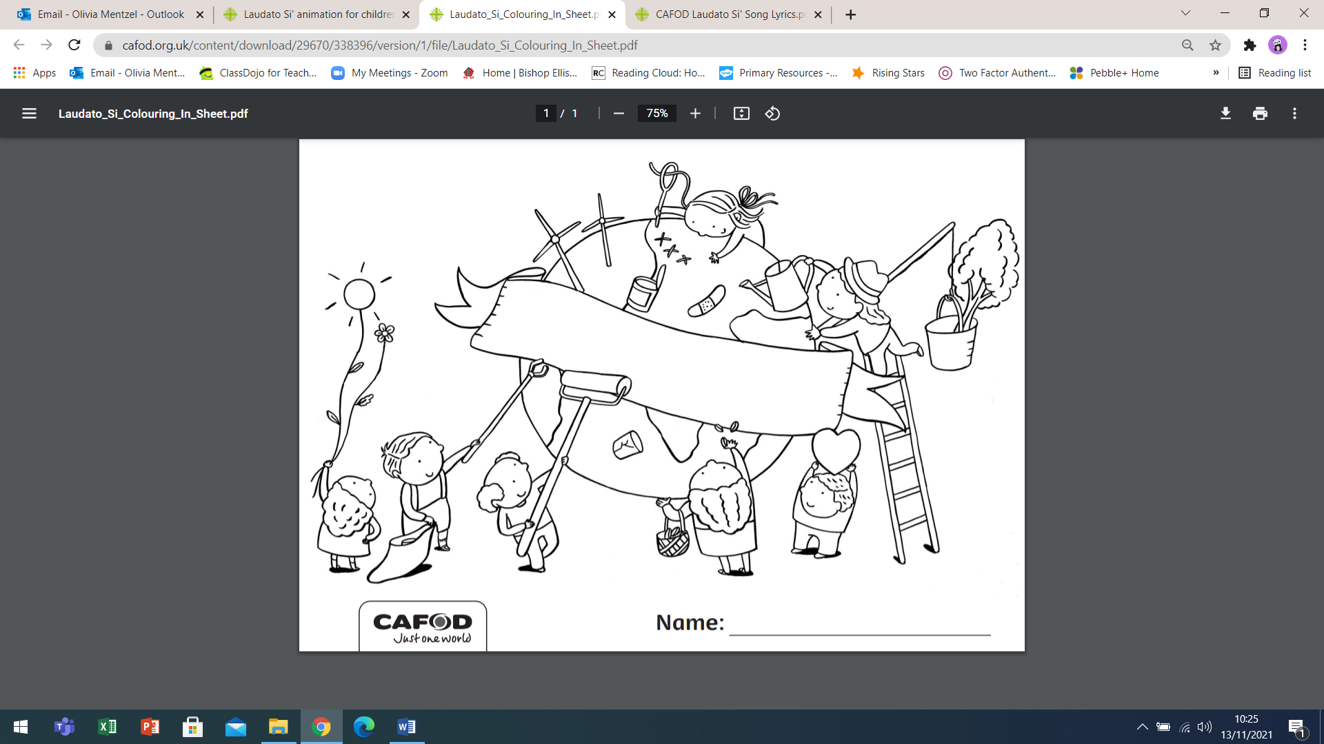

|  |
| --- |
| **Scripture Reading**  The evening meal was in progress, and the devil had already prompted Judas, the son of Simon Iscariot, to betray Jesus. Jesus knew that the Father had put all things under his power, and that he had come from God and was returning to God; so he got up from the meal, took off his outer clothing, and wrapped a towel around his waist. After that, he poured water into a basin and began to wash his disciples’ feet, drying them with the towel that was wrapped around him.  He came to Simon Peter, who said to him, *“Lord, are you going to wash my feet?”* Jesus replied, *“You do not realise now what I am doing, but later you will understand.”*  *“No,”* said Peter, *“you shall never wash my feet.”* Jesus answered, *“Unless I wash you, you have no part with me.” “Then, Lord,”* Simon Peter replied, *“not just my feet but my hands and my head as well!”* Jesus answered*, “Those who have had a bath need only to wash their feet; their whole body is clean. And you are clean, though not every one of you.”*  For he knew who was going to betray him, and that was why he said not every one was clean. When he had finished washing their feet, he put on his clothes and returned to his place. *“Do you understand what I have done for you?”* he asked them*. “You call me ‘Teacher’ and ‘Lord,’ and rightly so, for that is what I am. Now that I, your Lord and Teacher, have washed your feet, you also should wash one another’s feet. I have set you an example that you should do as I have done for you.”*  John 13:4-10  ------------  Jesus emphasised the importance of being of service to others, “the Son of Man did not come to be served, but to serve” (Mark 10:45). He revealed himself to be a servant-leader; someone who leads by example, by being in service to others.  **Why do you think Jesus puts service to others at the heart of being a disciple?**  ________________________________________________________________________________________________________________________________________________________________________________________________________________________________________________________________________________  *No matter what we do no matter how small it may seem that if we do it with love it will make a difference.* |
| **My Mission**  What is your mission - what are you called to do in your life?  Have a think about your vocation and what you are called to be. **Draw and write about it in the space below.**  ____________________________________________________________________________________________________________________________________________________________________________________________________________________________________________________________________________________________________________________________________________________________________________________________________________________________________________________________________________________________________________________________________________________________________________________________________________________________________________________________________________________________________________________________________________________________________________________________________________________________________________________________________________________________________________________________________________________________________________________________________________________________________________________________ |

|  |
| --- |
| Read this story of St Oscar Romero to help reflect on the theme of being a Servant-Leader.  **Oscar Romero**  St Oscar Romero, when he was made Archbishop of San Salvador in El Salvador in 1977, was seen as a safe pair of hands, someone who would not rock the boat. As the political climate began to change around him, when his own people were being threatened with violence, tortured, disappeared and killed, he decided that he needed to speak up. He chose to be on the side of the poor and oppressed in his country.  During his three years as archbishop, Romero repeatedly spoke out against the violence and used his voice to support the victims of the civil war. In a time of heavy press censorship, he used his radio station to broadcast news updates and his sermons to the poor farmers, which was often the only way people could find out the truth about the atrocities that were happening in their country. He defended the right of the poor to demand political change, a stance which made him a troublesome adversary for the country’s rulers.  St Oscar Romero, by standing with the poor, made many enemies who saw him as a very troublesome figure. It was extremely dangerous to stand up and be a voice for the poor. Although St Oscar Romero knew the risks he knew that he had to be faithful to the teachings of the Gospel. As he said:  *“A church that doesn’t provoke any crises, a gospel that doesn’t unsettle, a word of God that doesn’t get under anyone’s skin, a word of God that doesn’t touch the real sin of the society in which it is being proclaimed— what gospel is that?”*  Romero’s sermons were a lifeline of hope for so many of the Salvadoran poor. And as the violence started to increase, when families began to ‘disappear’ and murders were commonplace, Romero preached ever more forcefully on the theme of love and justice.  *"Let us not tire of preaching love; it is the force that will overcome the world. Let us not tire of preaching love. Though we see that waves of violence succeed in drowning the fire of Christian love, love must win out; it is the only thing that can."*  Romero is an inspirational figure to millions of Catholics around the world. He didn’t simply talk about the need to love your neighbour, but courageously named the injustices that plagued his country. He reminded us that Christ is found in people living in poverty, and that we cannot ignore the suffering of our brothers and sisters in need.  St Oscar Romero was one of the most remarkable figures of the 20th century, who deserves to be commemorated alongside the likes of Martin Luther King and Mahatma Gandhi as a peacemaker who sacrificed his life standing up to injustice. He was a true leader to the poor — a servant to his people. His witness continues to inspire, and his message of finding Christ in the poor is an important message for Catholics and the world today.  *“I believe that it is within us to care for others to reach out to those in need”.*  **Who do you see as a servant-leader? An inspirational leader who puts other’s needs before their own?**  ____________________________________________________________________________________________________________________________________________________________________________________________________________  **What qualities should a servant-leader have? Write a list below.**  ________________________________________________________________________________________________________________________________________________________________________________________________________________________________________________________________________________  **If Oscar Romero was alive today, what do you think he would be saying?**  ________________________________________________________________________________________________________________________________________________________________________________________________________________________________________________________________________________  **What Faith in Action service have you done or could you do, that show you care about people living in poverty or with injustice?**  ____________________________________________________________________________________________________________________________________________________________________________________________________________________________________________________________________________________________________________________________________________________ |

|  |
| --- |
| **Oscar Romero Quotes**        **Which quote from Oscar Romero appeals to you? Why?**  ____________________________________________________________________________________________________________________________________________________________________________________________________________________________________________________________________________________________________________________________________________________________________________________________________________________________________________________________________________________________ |

**Design an inspirational postcard using quotes from Oscar Romero.**

|  |
| --- |
|  |

**Write an inspirational message on your postcard, encouraging the recipient to serve others. Give some specific examples of ways in which they can show service to others.**

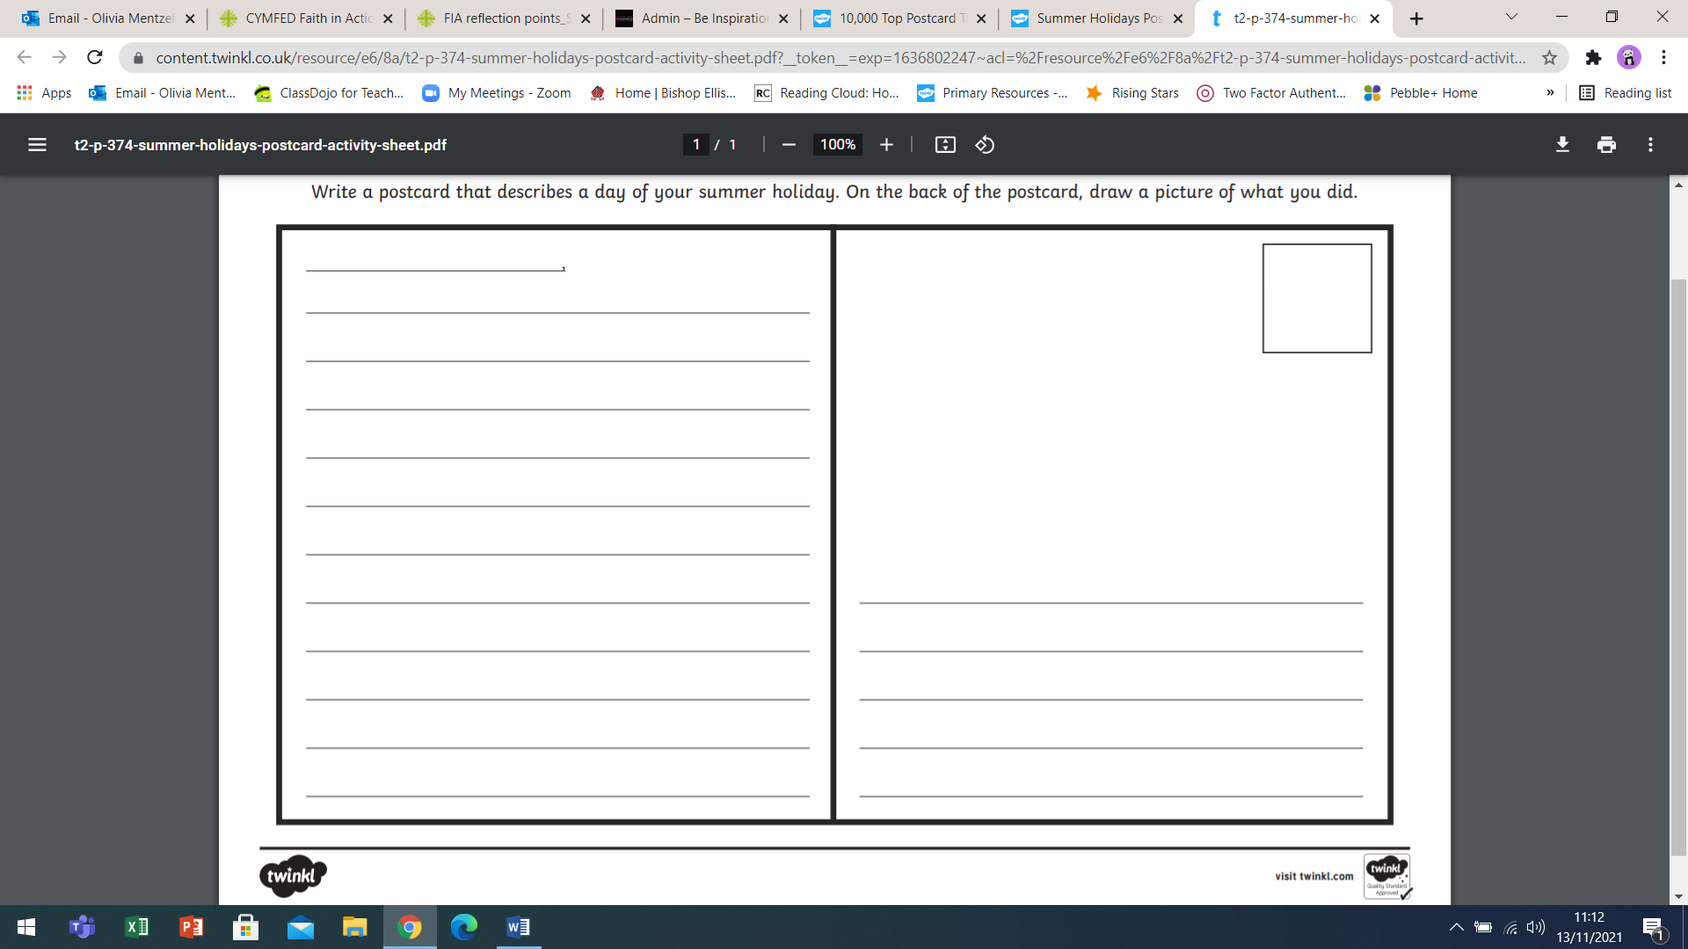

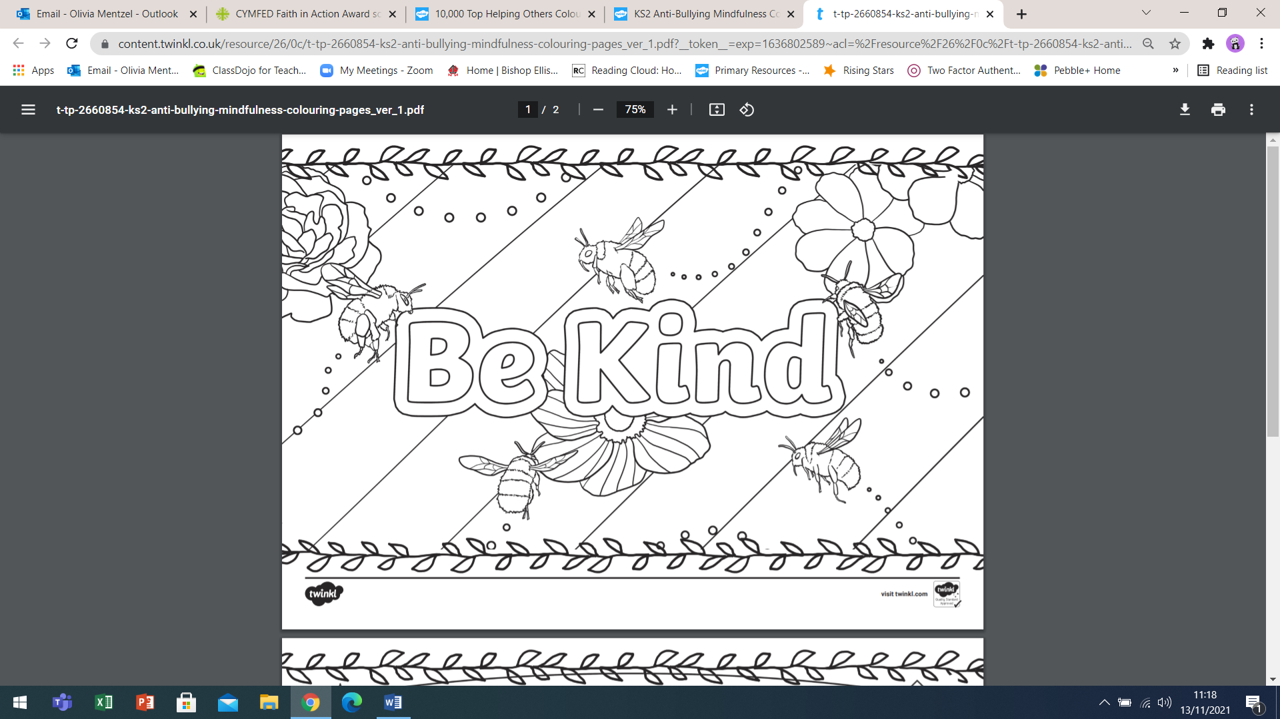

**How can you show kindness to others?** ____________________________________________________________________

_______________________________________________________________________________________________________

**Faith In Action**

**Draw some pictures of different ways we can show our faith in action.**

**Write about the different ways you have chosen to draw.**

___________________________________________________________________________________________________________________________________________________________________________________________________________________________________________________________________________________________________________________________________________________________________________________________________________________________________________________________________________________________________

___________________________________________________________________________________________________________________________________________________________________________________________________________________________________________________________________________________________________________________________________________________________________________________________________________________________________________________________________________________________________

___________________________________________________________________________________________________________________________________________________________________________________________________________________________________________________________________________________________________________________________________________________________________________________________________________________________________________________________________________________________________