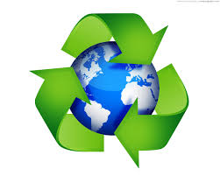

Our eco code

This is our eco code, Take the good road,

Pick up litter from the floor,

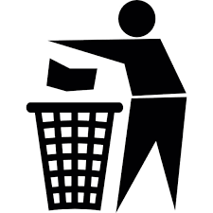Then good things will come to your door,

Put rubbish in the bin,

Don’t forget about the tin,

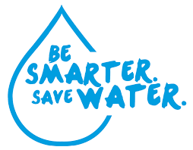Save the water that we have,

Even when we have a bath,

Turn off the taps when you’re done,

Saving water is good fun,

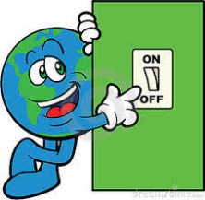

When you leave the room turn off the light,

Don’t forget about the night.

