Our eco code
Bin your litter
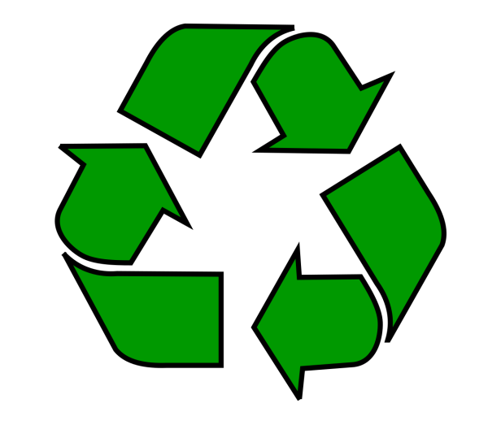
It’s good to do
Saving water
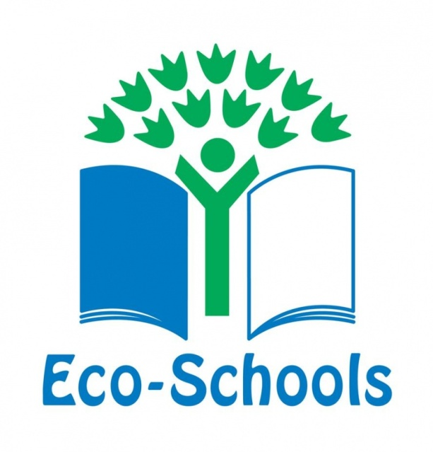
Helps us too
Our school should
Protect the world for you
Electric isn’t good to waste
Lights should be turned off post -haste
Life will be better if you recycle
It’s our job to
Save our planet!!

