Creating a Dyslexia Friendly Classroom



Handbook for Class Teachers & LSAs

The ‘Dyslexia Friendly Classroom
What should it be like?
SEATING

When seating pupils, try to ensure they are….
- At the front, facing the board;
- Near to the class teacher where possible (so help can be offered readily);
- Seated to minimise disruption and concentration maximised – displays/visual stimuli behind the pupil;
- not ‘crowding out’ (left handers clashing with right handers);
- Sitting with good posture, request footrest/writing slope/seat wedge if posture is poor.
- Seated in well lit areas.
EQUIPMENT
Have readily available:
- Triangular pens/pencils or pencil ‘grips’.
- Line trackers, bookmarks, overlays as appropriate;
- Handwriting paper and ‘guidelines’.
- Resources to support multi-sensory teaching;
- Spelling aids: dictionaries, word cards, personal spelling logs, electronic spelling checkers, hints cards/booklet.
Desktop baskets/individual packs should include:
Literacy:
- Alphabet strips/arcs, with vowels shown in red (showing both upper and lower case);
- Cue cards re; spelling rules currently taught;
- Laminated memo cards (for date, key words, reminders…);
- Most frequently needed equipment (pencil, pen, ruler, workbook).
Numeracy:
- Most frequently needed equipment (number line, 100 square…)

CLASSROOM ROUTINES

State clear purpose for each lesson.
Display class timetable – provide visual timetables for pupils to use at school and home.
Organise equipment effectively, label with visual/colour cues where possible.
Have an agreed location for finished work to be placed.

LANGUAGE
- Avoid sarcasm and rhetorical questions (Dyslexic children can take language literally);
- Speak slowly and clearly, using short sentences – repeat key words;
- Vary tone of voice;
- Pre-teach subject specific vocabulary.

- Give verbal instructions clearly and one at a time – ask pupil to repeat back to check understanding;
- Stress key words;
- Back up instructions visually – written/visual reminders displayed on class board or own memo card;
- Check homework instructions are written legibly/clearly – be prepared to scribe sometimes;
- Give homework instructions in the first part of the lesson if possible.

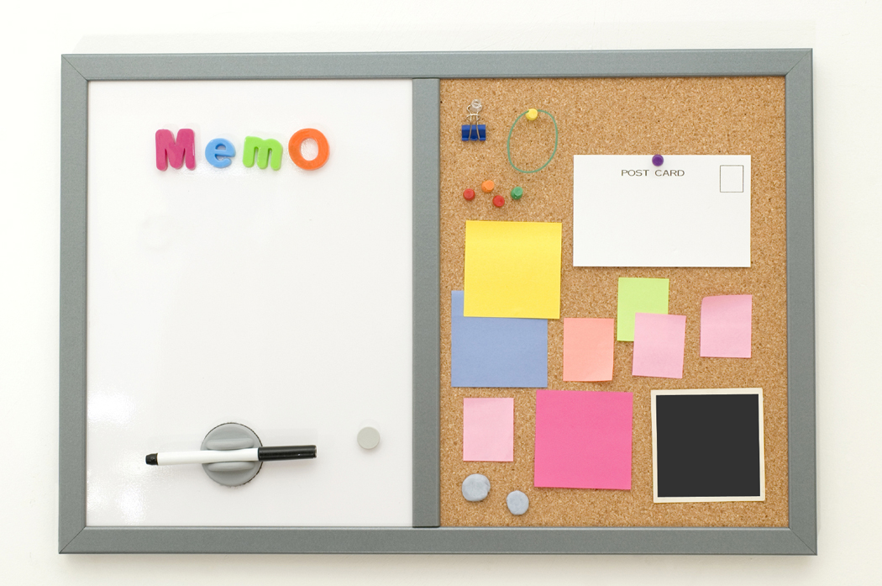
- Display most commonly needed information:
- Key word lists: high frequency words, word ‘families’, topic vocabulary;
- Times table charts;
- Number/hundred square;
- Useful lists: days of the week, months of the year.

- Read aloud as you write;
- Use coloured pens, vary colours used for lines/sections (to ease tracking difficulties);
- Do not stand where obstructing view;
- Try to avoid pupils copying from the board where possible - Think about the purpose of the copying, does it link to lesson objective?!
- Allow plenty of time to complete;
- Give pupils a copy of what is on the board – copying/reading close work is easier.
- Give typed photocopies – pupils can highlight key words/facts rather than copying.


- Use bold headings and clear print – well spaced, not too small!
- Make sure they are at an appropriate reading level (differentiate!!)
- Use less writing, more diagrams and/or pictures;
- Cut out unnecessary detail;
- Consider use of coloured paper to ease visual stress (ie pale blue, cream etc).

- Consider alternative means of recording (a scribe, paired/collaborative work, tape recorder/Dictaphone, video, laptop, illustrated diagrams/charts;
- Provide framework/scaffold for writing, with headings, sentence beginnings etc
- Encourage pupil to record ideas initially, without worrying excessively about spelling;
- Attach lists of useful words to exercise books;
- Encourage use of own spelling log/word cards;
- Develop use of mnemonics for ‘tricky’ words;
- Have key words displayed in classroom;
- Allow more time and expect less in terms of quantity.

- Check suitability of texts – may need to simplify;
- Do not ask pupil to read aloud (unless she/he wants to);
- Read instructions to the pupil where appropriate;
- Encourage paired reading.
READING


- Encourage the use of word processing, with built in spell checker (which can minimise handwriting and spelling problems, use of predictive programmes (such as ‘Pen friend’);
- Provide a large mouse or tracker ball for pupils with sever motor difficulties;
- Encourage own portable, electronic spell checkers;
- Dictaphones have a range of uses: recording own stories, details of homework, things to remember;
- Alternatives of recording in literacy tasks (see handbooks for additional methods to those listed above);
- Talking calculator.
ICT

Marking work

- Mark pupils work with him/her wherever possible (sit on same side of the desk);
- Return marked work as soon as possible (if collected in)
- Written comments should be clearly printed and legible;
- Avoid excessive use of ink!
- POSITIVE MARKING - Balance positive comments with points for development;
- Be specific about focus of marking (are you judging ‘’authorial or ‘secretarial’ skills?);
- Do not correct ALL spelling errors – target specific errors which pupils can reasonably address;
- Judge content separately from presentation;
- Try to judge oral responses to some tasks (rather than written ones) – you may be surprised at the level of understanding that the child is unable to portray in their work!

Should NOT be a substitute for well-differentiated tasks;
Establish clear procedures for pupils to access help eg put up hand and wait for attention, stand by teacher’s desk (as per classroom routines);
Beware of ‘learned helplessness’ – the pupil who relies too heavily on the Class Teacher/LSA;
Try to timetable regular slots for additional, target teaching – pupil should be aware of time/location (eg Nessy).

- Create an uncritical atmosphere
- Give opportunities to succeed.
- Avoid sarcasm
- Praise success and give rewards frequently.
- Remember, dyslexic children have to put far more effort into completing tasks – be mindful of this when looking at work completed.
- Match tasks to concentration span – allow breaks/time out to run errands, clean board etc.

Multisensory Teaching
“We hear, we forget,
We see, we remember.
We do, we understand.”
(Chinese proverb)

Auditory (Hear)

Visual (See)

Oral (Say)

 Tactile (Touch)
Kinaesthetic (Motor/movement)
__________________________________
- Use a combination of auditory and visual ‘channels’ for giving information.
- Ensure planning is differentiated, backtracking to previous year group objectives where appropriate.
- All tasks planned should be achievable.
- Begin each lesson by stating clear objectives, make desired outcomes clear and finish with a plenary, recapping on what has been taught.
- Ensure all adults in the class are aware of children’s strengths, weaknesses and current targets.



Nessy is an interactive, multi-media intervention programme with a variety of games that offer repetition so children can practise specific areas of weakness, with regards to reading, writing and spelling. It contains 120 lessons, following a structured, phonic approach, that are supported by printable card and board games (259), activity sheets, rules and word lists (1500), mnemonics (library) and computer games (586 versions of 12 animated computer games). It also has animated spelling rules and story books with decidable text.

Please ensure focus children (children with Dyslexia or present with some aspects of Dyslexia) access Nessy on a daily basis, for a minimum of 10 minutes.

All computers in the ICT suite have this loaded. It is available for upload on classroom computers if requested (see JC).

Additional Intervention

Stile dyslexia, Alpha to Omega, Toe by Toe and other interventions are still available from the learning support room. The ICT suite also has Memory Booster that will be beneficial to many children. If you have a particular concern, speak to the SENCO (JC) who will do her best to resolve.

Additionally, I am able to conduct the GL Assessment Dyslexia Screener to highlight particular difficulties and support children as per their needs.

