**Absence Request Application Form**

|  |
| --- |
| Name of Child(ren): |
| Class teacher(s): |
| Date of Absence:  From: To: |
| Please note:   * There is no right to a family holiday during term time. However, consideration will be given by the governing body in **exceptional circumstances only**. Days in excess of the agreed period will be marked as ‘unauthorised absence’ and recorded on your child’s school record accordingly. * If permission for absence is given, your child’s attendance record will still be affected. * Any holiday leave taken without prior consultation with the school will be marked as ‘unauthorised absence’. * Pupil assessments take place in April, May and June (Year 1- see newsletter dates). Holidays **will not** be authorised during this assessment period. * Requests will be refused if your child already has a poor record of attendance or if national tests are taking place at the time of the holiday. The Local Authority classes pupils with attendance of below 90% as ‘a persistently absent pupil’. Poor attendance is monitored by the Attendance Improvement Officer and unauthorised absence can lead to a visit or a fixed penalty notice. |
| Please give details of why this absence is ‘exceptional and indicate the reason why this could not take place in the course of the normal holiday pattern (proof may be required e.g. letter from employer): |
| Signed: Date: |

________________________________________________________________________________________________________________________

**Reply from Headteacher on behalf of the governing body:**

Name of Child(ren)__________________Class__________% Attendance___________

___________________ __________ ___________

|  |
| --- |
| I am able/not able to give permission for you to take your child/children out of school:  From: To: |
| Comment: |
| Signed: Date: |

|  |  |
| --- | --- |
|  | Bishop Ellis Catholic Voluntary Academy  Barkby Thorpe Lane  Thurmaston  Leicestershire  LE4 8GP  Tel: 0116 2695510  E-mail:admin@bishopellis.leics.sch.uk |

Dear Parent/Carer,

**Family holidays during term-time**

An increasing amount of pupil absence each year is caused by taking holidays during term-time. Absence from school disrupts continuity of learning, undermines educational progress and can lead to underachievement and low attainment.

Please bear in mind that parents do not have the right to leave of absence for holidays in term-time; permission is granted at the discretion of the head teacher on behalf of the governing body of the school. New guidelines from the Department of Education states:

*“Amendments to the 2006 regulations remove references to family holiday and extended leave as well as the statutory threshold of ten school days. The amendments make clear that Head teachers may not grant any leave of absence during term time unless there are exceptional circumstances. Head teachers should determine the number of school days a child can be away from school if the leave is granted”.*

All parental requests for term-time holidays should be made by completing an

Absence Application Form explaining the reason for the exceptional request, prior to booking the absence. When considering whether permission will be granted, the school will examine the child’s general attendance record and other factors such as whether there are national tests or public examinations during the proposed period of absence.

Cheaper holidays, second or third family or surprise holidays, long weekends or further weeks, days out with grandparents or friends, shopping trips etc. **do not** fall into the category of exceptional absence. Any such absences would be **un**authorised and could lead to a referral to the Attendance Improvement Service.

I hope that you will support the school in this matter. Should you wish to discuss the matter further, please do not hesitate to contact me.

Yours sincerely,

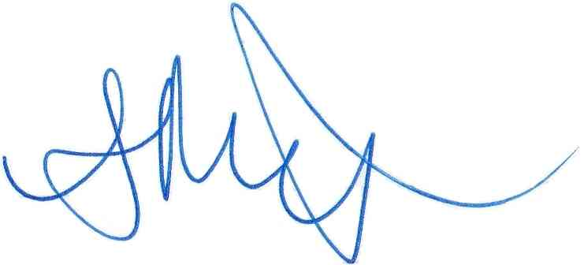

Andrew Monaghan

Headteacher