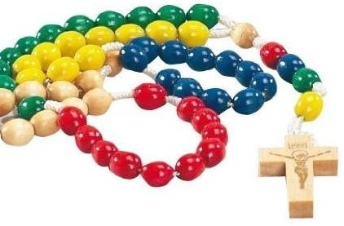 A Rosary

for children to pray for Ukraine and Russia.

With the older children, on the beads between the cross and the medal, you may wish to pray –

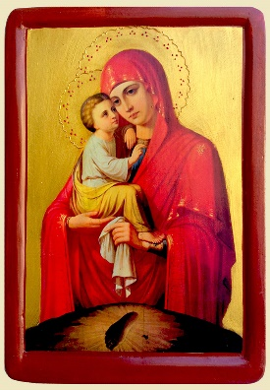Our Father, 3 Hail Mary’s and a Glory Be.

For all 5 decades -

On each of the 10 small beads pray – ***Our Lady of Ukraine, pray for us***

On the large bead in between pray – ***Glory be to the Father.***

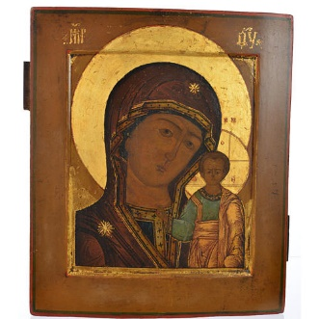***Having finished 5 decades as above, begin again but now-***

On each of the 10 small beads pray – ***Our Lady of Russia, pray for us***

On the large bead in between pray – ***Glory be to the Father.***

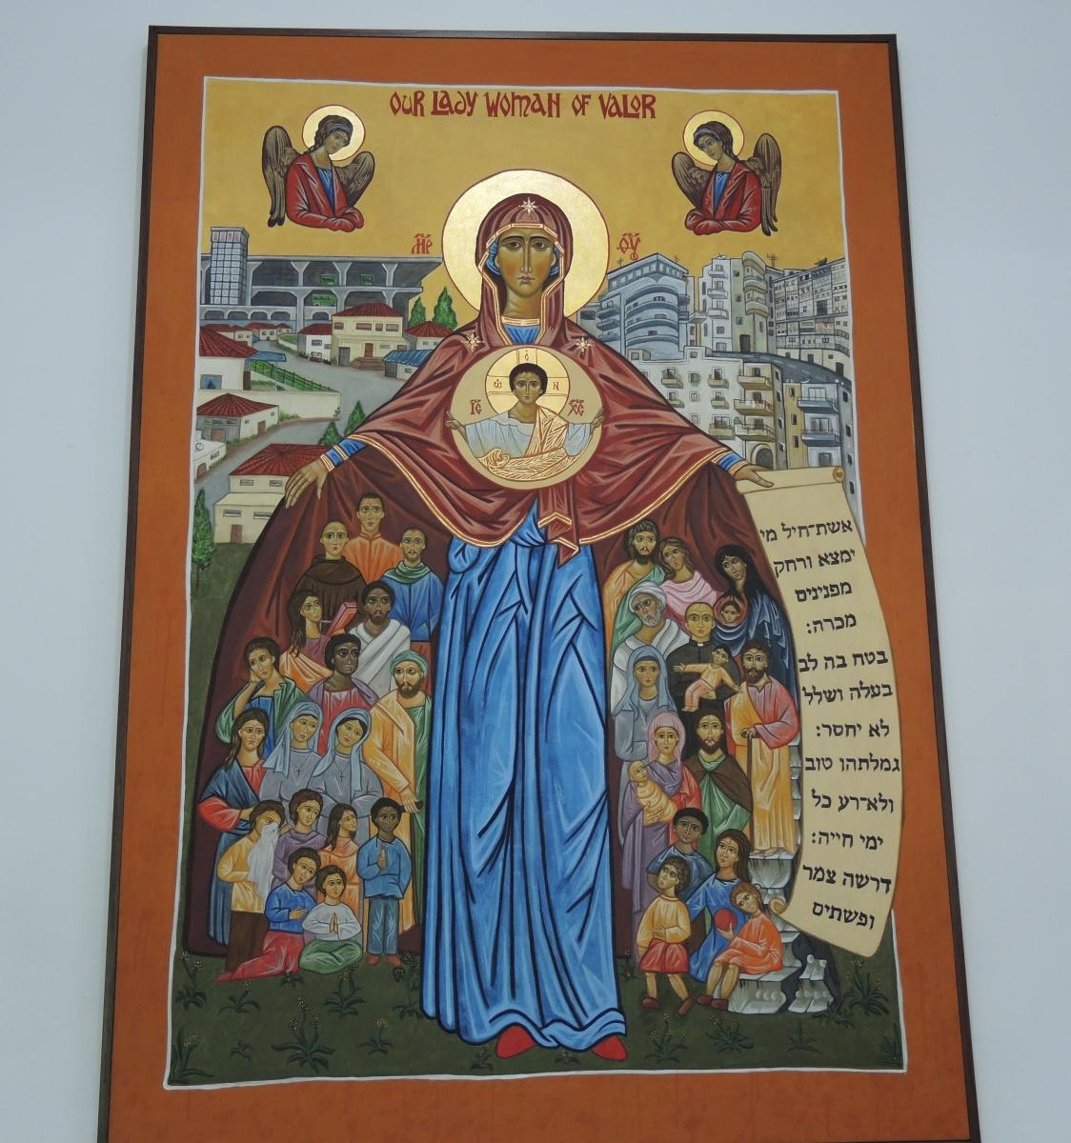***Having finished 5 decades as above, begin again but now -***

On each of the 10 small beads pray – ***Our Lady of Refugees, pray for us***

On the large bead in between pray – ***Glory be to the Father.***

***Having finished 5 decades as above, begin again but now –***

On each of the 10 small beads pray – ***Our Lady of helpers, pray for us***

On the large bead in between pray – ***Glory be to the Father.***

***Having finished 5 decades as above, begin again but now –***

On each of the 10 small beads pray – ***Mary, Queen of Peace, pray for us***

On the large bead in between pray – ***Glory be to the Father.***

*(for younger children, you may wish to just have one decade with each invocation)*

***End by praying the Hail Mary together.***